 ­­­

01.26.2014 • Version: 1.1 • Prepared by: Lightwellinc

Upgrading a USFS 8.0 Scan Gun to version 9.1

*Prepared for:*

FS & BLM Users

(Lightwell Team will help you if you have questions)



Table of Contents

You will need: 3

Upgrading a USFS 8.0 Scan Gun to version 9.1 3

# You will need:

* You will need the following 3 files

(Lightwell Team has copies of these files if you face any difficulties):

* + YantraHostList.xml



* + YantraMobileApp_WCE4_5.ARMV4.CAB



* + OnRestore.txt



* You will need a Scan Gun Power/USB adapter.
* You will need a Windows 7 (64 bit) machine.

# Upgrading a USFS 8.0 Scan Gun to version 9.1

* Plug the Power end into an outlet.
* USB into your computer. (USB 2.0 port, NOT a USB 3.0 port)
* Connect the scan gun.
* You should see the software automatically start to install:
  + This is standard Windows software for Mobile devices. Please ALLOW Windows to install this software. If you get any prompts say “yes”/”accept”/”I Agree”/etc…. Please DO NOT block this software from being installed in any way.

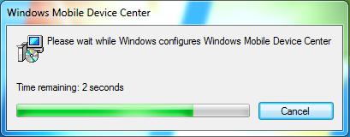

* Click: Start – Search “Windows Mobile Device Center”. Open it.

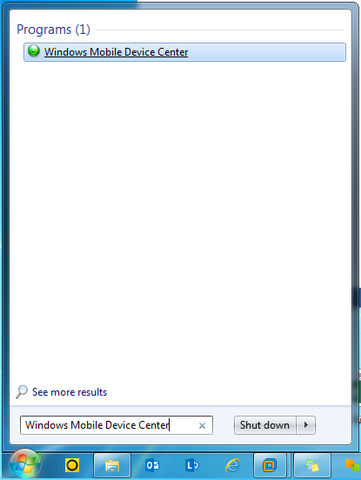

* You should see that it has a status of “Connected”.

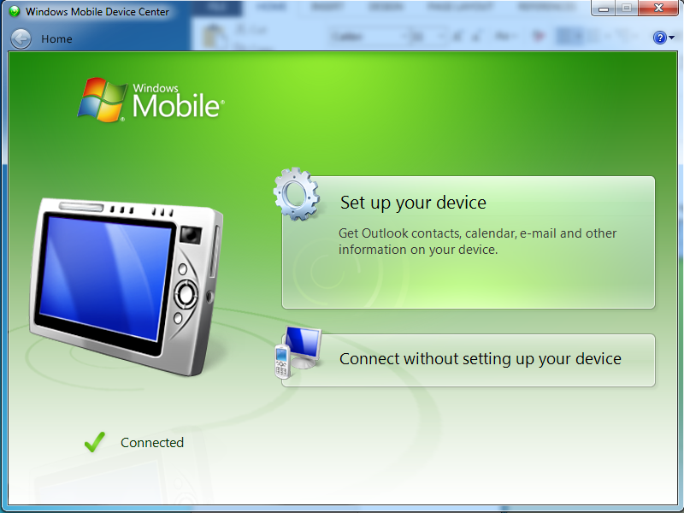

* IF you should see that it has a status of “Not Connected”.
  + You may have to “accept” the government warning before the scan gun will connect. (on the scan gun itself)
  + Also, it seems to only work with your USB 2.0 port on your computer. (NOT your USB 3.0 port) If unfamiliar with this concept, ask your system administrator for more information.

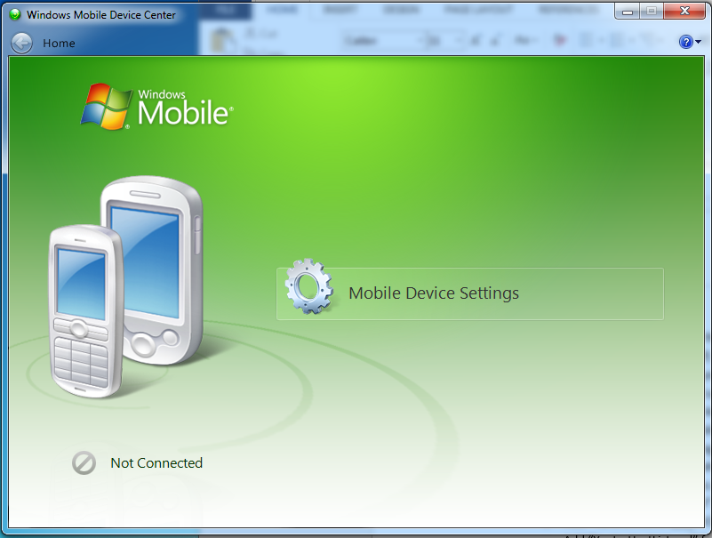

* Click: “Connect without setting up your device”.
* Click: “File Management” - “Browse the contents of your device”.

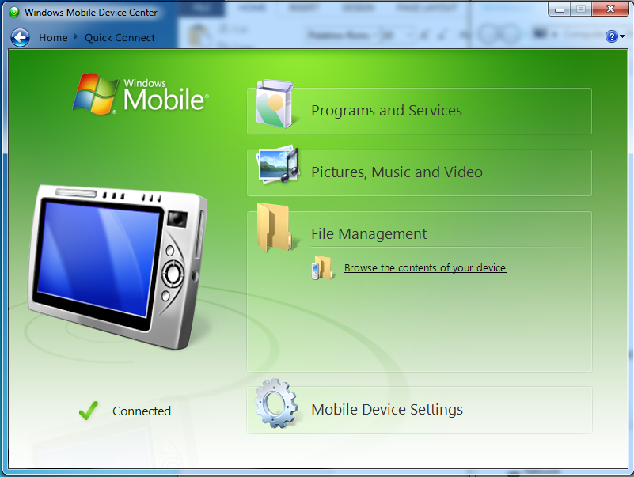

* Browse to: “Application”.

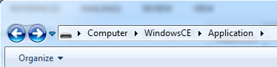

* + Delete “YMAProperties.ppc.xml”.
  + Delete “YantraHostList.xml”.
  + Add “YantraMobileApp_WCE4_5.ARMV4.CAB”.
    - (Drag & Drop the file)
  + Add “YantraHostList.xml”.
    - (Drag & Drop the file)
* Browse to: “StartUpCtl” – “OnRestore”:

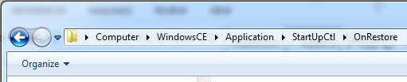

* + Delete “YantraMobileAppWCE4.ARMV4.CAB”.
  + Add “YantraMobileApp_WCE4_5.ARMV4.CAB”.
    - (Drag & Drop the file)
  + Add “OnRestore.txt”.
    - (Drag & Drop the file)
* Perform a “Cold Boot”.
* Connect to a network.
  + IF you are using your USFS or BLM wireless network then login like normal.
  + Otherwise ask your system administrator for another network and have him/her connect your scan gun to this other network.
* Launch the Sterling Mobile Console.
  + You will see 3 new options for 9.1 environment that you can choose from in the dropdown. Select the one you want and login with your id.
    - QA
    - Training
    - Production